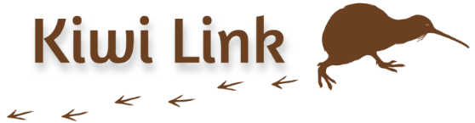
Kiwi Link

HVA Annual Report
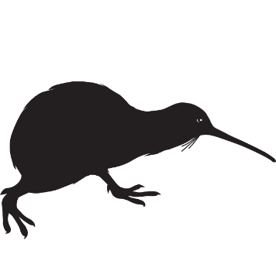
July 2025

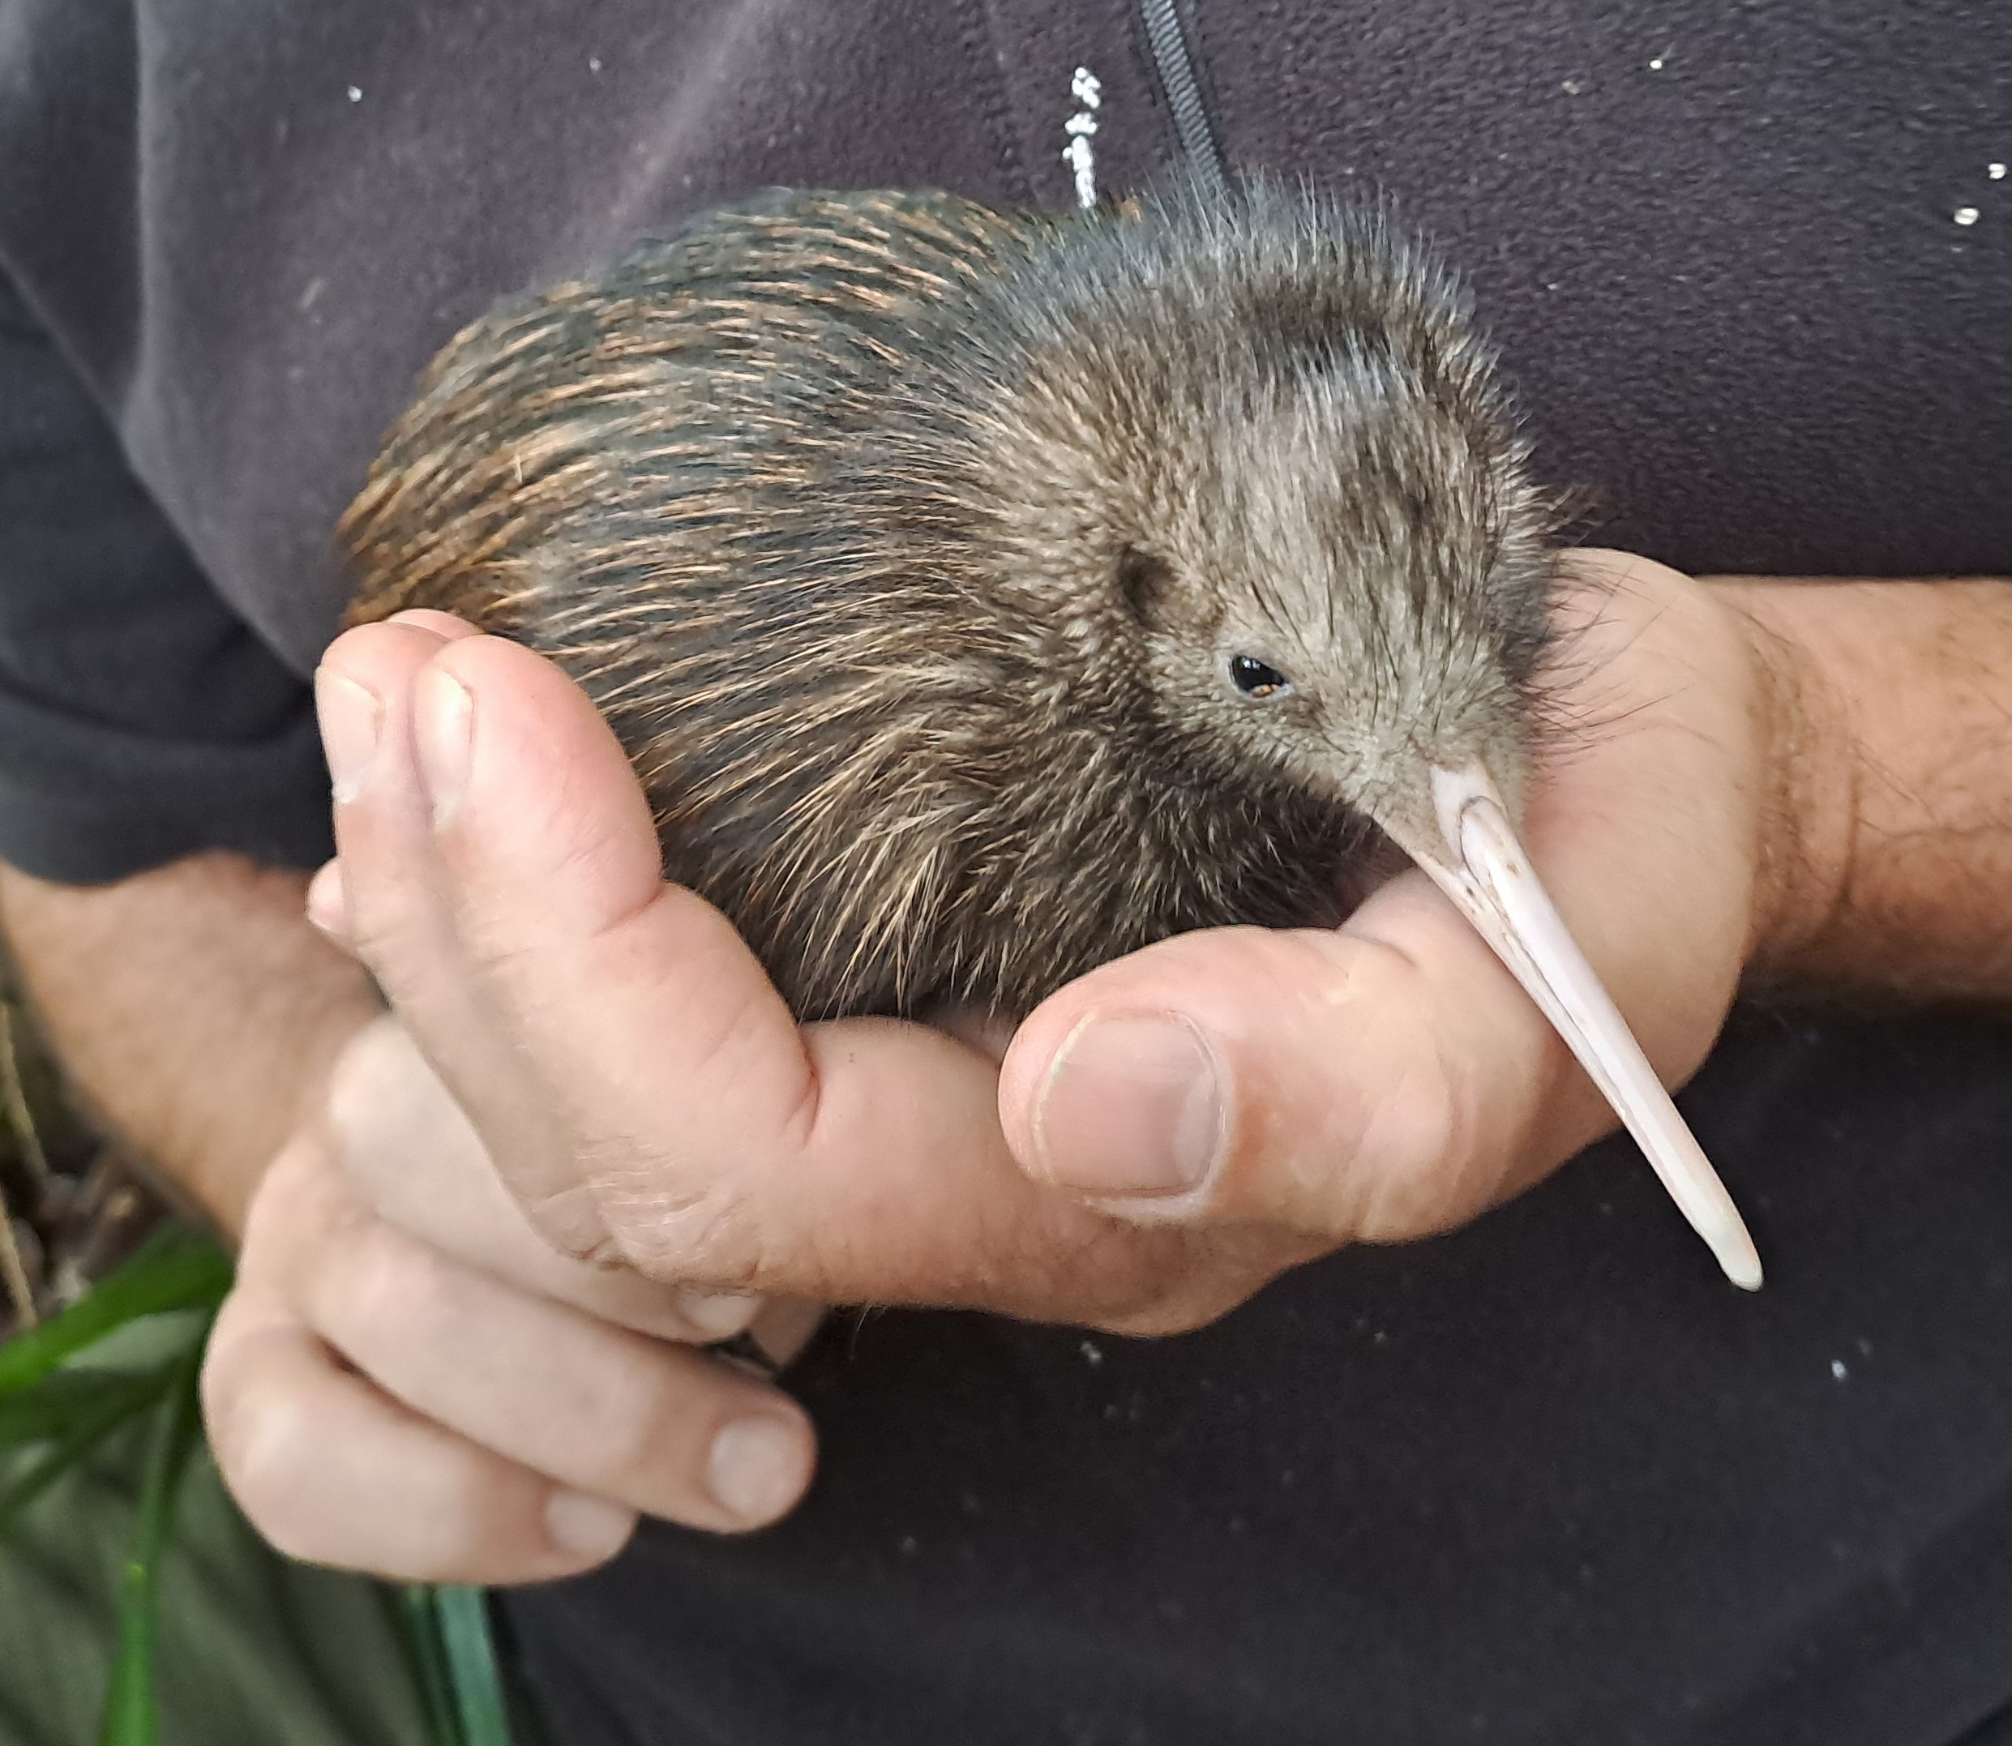
Abby – would it work to cut out the kiwi chick and the hand coming in from the right or is it good just as it is?

Table of Contents

______________________________________
Background 3
______________________________________
Activities 4
______________________________________
Kiwi Link Groups and Projects 5
______________________________________
Financial Summary 6
______________________________________
Objectives 8
______________________________________
Communication & Engagement 11
______________________________________
Monitoring 12
______________________________________
Summary 20
______________________________________
Cover: Chookie the kiwi’s chick, Owhiwa. October 2024.
Photo: Todd Hamilton
Appendices
______________________________________
Appendix 1: Kiwi Link NRC HVA
Budget & Expenditure
July 1 2024 - June 30 2025 21
______________________________________
Appendix 2: Kiwi Link HVA
Financial Contributions,
July 1 2024 – June 30 2024 21
______________________________________
Appendix 3: Kiwi Call Monitoring
Results 2020 - 2024 22
______________________________________
Appendix 4: Update of Radio
Transmitted Kiwi in or near the
southern end of the Kiwi Link area. 25
______________________________________

Background
The vision of Kiwi Link is “Flourishing flora and fauna, with abundant kiwi roaming safely between Taraunui and Ngunguru Ford by 2036”.
Community-led conservation groups involved in Kiwi Link have worked together since 2017 to protect and restore native biodiversity between Taraunui and Ngunguru Ford in eastern Whangarei.
This project is named the ‘Kiwi Link’, as the primary goal is to rebuild kiwi populations and connect the kiwi strongholds of the Whangarei Heads peninsula and the Tutukaka Coast.
Initially, Kiwi Link involved eight projects working together over 13,624ha. This has grown to a coordinated network of 11 community-led groups and conservation projects. The combined project area has now increased to approximately 15,000 hectares. Map 2 shows the location of the group and project areas.
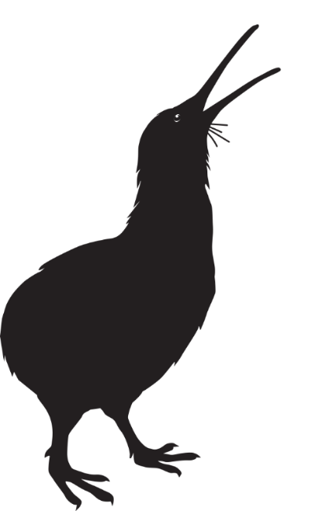
This report summarises the results and achievements of the Kiwi Link HVA from
July 1 2024 – June 30 2025.

Community-led groups and Conservation projects involved
in Kiwi Link:
Glenbervie Landcare
Harris Rd Area Landcare
Kohinui Stream Landcare
Manulife Whanui Project
Ngunguru Ford Landcare
NRC Mt Tiger Forestry Block
Owhiwa Landcare
Pataua North Landcare
Taraunui Landcare
Taheke Landcare
Whareora Landcare

As Kiwi Link grows, it seeks to further strengthen relationships with hapū and iwi and work in partnership to revitalise the native wildlife, forests, wetlands, and coastal systems of the area. The growing relationships with Ngāti Kahu o Torongare, Ngāti Korora, Ngāti Takapiri, Te Parawhau, Te Waiariki and Ngātiwai are greatly cherished. It is hoped that we can continue to deepen these connections and work further with tāngata whenua as opportunities emerge.

Activities
Over the past 12 months
Kiwi Link has:
Worked together as communities and land managers to restore native flora and fauna between Taraunui and Ngunguru Ford.
Deployed new predator traps and bait stations to expand and fill gaps in the ever-growing predator control network.
Coordinated animal and plant pest operations with willing landowners for maximum efficiency and effectiveness.
Protected and grown the small remnant kiwi populations.
Tracked the survival, dispersal and breeding success of released kiwi.
Implemented robust outcome monitoring measures to track progress towards goals.
Supplied landowners with resources to help them operate at their full potential.
Supported each group involved with sustained professional predator control.
Motivated and empowered further landowners to actively get involved
Worked collaboratively with mana whenua, Kiwi Coast, Northland Regional Council, Department of Conservation, QEII National Trust, Predator Free 2050 and neighbouring projects to progress the creation of New Zealand’s first kiwi corridor.
Animal and plant pest species controlled through the Kiwi Link project area includes:
Animal pests
Possums
Rodents
Mustelids
Feral cats
Feral pigs
Myna
Magpies
Hedgehogs
Wasps

Plant pests
Banana passionfruit
Climbing asparagus fern
Elaeagnus
Jasmine
Moth plant
Pampas
Queen of the Night
Small and large-leaved privet
Smilax
Taiwan Cherry
Tradescantia
Wild ginger
Wilding pine
Woolly nightshade

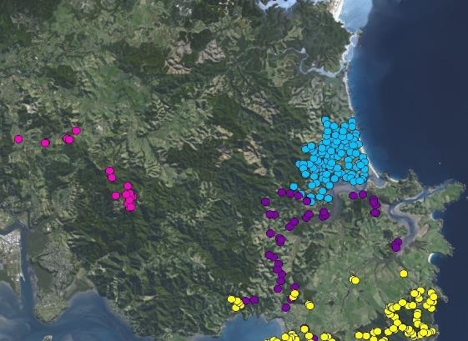
Map 2: Kiwi Link HVA Groups & Predator Traps, 2024. Map: Biospatial
Map 1: Predator traps, 2013. Map: NRC

Financial Summary
A breakdown of expenditure of the NRC’s HVA $131,240 contribution to Kiwi Link over the past financial year is provided in Appendix 1.
NRC’s contribution represented 20% of the total project value. This core funding was increased five-fold, with a total of $637,537 resourcing Kiwi Link operations and activities over the past year (see Table 1).
Figure 1 – financial contributions pie graph
Unpaid labour by local landowners (costed at $30/hour) was the single largest contributor, totalling $167,170. The Kiwi Coast Trust also supplied resources and support worth $43,374.

Other financial contributions were made by the Predator Free Whangarei Project,
QEII National Trust, Manulife Forestry,
Airzone, Martin Trust, Tahi Estate and generous local sponsors keen to help and be involved (see Figure 1).
The Department of Conservation also provided in-kind support - assisting with predator trapping, kiwi releases and monitoring.

Table 1: Kiwi Link HVA Financial Summary & Contributions 1 July 2023 - 30 June 2024 (excl. GST)

See Appendix 2 for further details.
Objectives
2
Kiwi Link HVA has progressed
all five of its key objectives:
1
Enable groups to carry out efficient and effective integrated animal and plant pest control

Kiwi Link budget priority was given to ensuring professional predator trappers under contract to Kiwi Coast were resourced to complete all trapping rounds for each project to complement the unpaid pest control work of the many landowners involved.
Continuing to build the skills and the capacity of landowners was also a priority. Resources provided upon request to groups included traps, lures, toxins, bait stations, herbicides, monitoring tools and safety equipment. The Kiwi Link Coordinator provided technical and health and safety advice to all landowners and group leads as products were received or distributed.
Thanks to increased funding from NRC, all landowner requests for animal and plant pest control products were met.
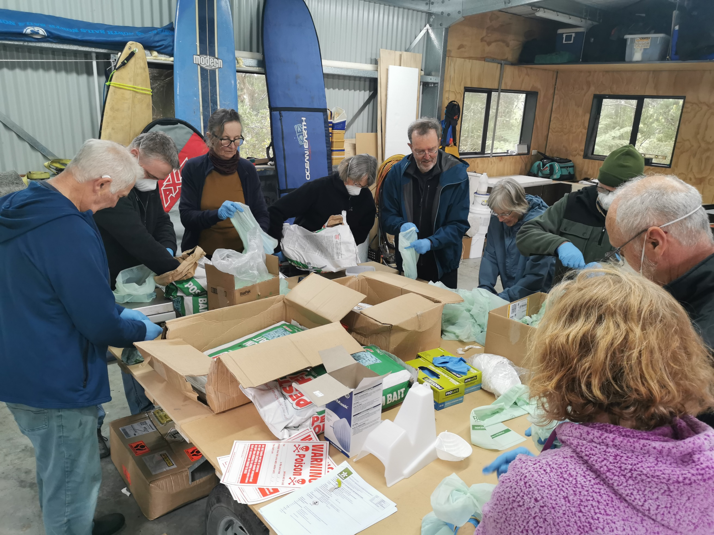
Kohinui Stream Landcare toxin bagging working bee, August 2025. Photo: Kiwi Link

Complete a
continuous predator
control network

The Kiwi Link predator trap network targeting feral cats and mustelids (weasels, stoats and ferrets) has been continually expanded, linked and infilled since the project began.
There is now an extensive collaborative predator trap network covering the 15,000ha project area. Predator traplines of neighbouring projects are back-to-back in many places, ensuring predators have optimal opportunity to encounter devices across the landscape. Maps 1 and 2 show the considerable progress made to date.
Kiwi Link is also at the core of a wider 60,000ha Mustelid Suppression Network supported by Predator Free Whangarei. A key focus of the network has been infilling and extending bait station lines with private landowners, QEII covenantors, exotic forest managers and community groups. Great progress has been made, but there is considerable work to do to make a continuous bait station network a reality.

3
4
Coordinate animal and plant pest control operations to maximise efficiencies and biodiversity gains

Each winter, special emphasis is put on a coordinated pest knockdown with willing landowners via a controlled toxin pulse to reduce pest populations at scale. Different toxins continue to be pulsed and cycled to ensure that pest control remains effective and biodiversity goals can be achieved
Thanks to dedicated expert technical support from the NRC Biosecurity Team, XX community-led ground-based operations of toxins with secondary poisoning effect (sodium fluoroacetate and brodifacoum) have also been supported over the last XX years, covering XX ha.
Controlled pulses of toxins with secondary poisoning effect are crucial for the control of untrappable pests that are unwilling to interact with traps. Over time as numbers of untrappable pests build in an area, attempting to control pests by trapping alone becomes ineffective.
The removal of trap-shy pests, especially predators such as stoats, will have greatly increased the breeding success of native wildlife. As stoats predate 95% of kiwi chicks in areas where there is no, or ineffective, management of mustelids, such operations are critical to re-building Kiwi Link’s kiwi population.

Rebuild Robust
and Resilient
Kiwi Populations

Kiwi Link utilised a multi-pronged approach to rebuild kiwi numbers and ensure populations are genetically robust.
Firstly, the breeding success and survival of existing kiwi were protected and enhanced with intensive professional predator control and secondary toxin pulses at key sites.
Kiwi Link also worked with Backyard Kiwi, Kiwi Coast, DOC and Northland Regional Council to support kiwi releases into Owhiwa.
Four kiwi from the Matakohe-Limestone Island creche were released into Owhiwa in 2025. The subsequent monitoring of these kiwi via leg-fitted radio transmitters has enabled their survival, dispersal and breeding success to be followed (see Appendix 4).
The fresh genetics brought into Kiwi Link by the released kiwi will help to ensure the genetic robustness and long-term viability of the area’s kiwi populations.
The opportunities generated by the telemetry monitoring to share kiwi stories, increase understanding of the need for quality pest control and engage local landowners in dedicated dog control are also key ways of ensuring Kiwi Link kiwi will thrive into the future.
5
Improve Coordination
and Effectiveness of
Plant Pest Control

A potential negative effect of animal pest control is an increase in plant pests as browsing of foliage decreases and more pest plant seeds are dispersed by an increased number of birds. Groups involved in Kiwi Link continued their plant pest control, targeting the most pervasive weeds as a priority.
In the past 12 months alone, landowners and managers contributed $84,160 of plant pest control labour. This demonstrates the huge amount of effort going into the Kiwi Link area to keep invasive plant pests at bay.
Landowners tackled Taiwan Cherry, ginger, climbing asparagus, pampas, banana passionfruit, jasmine, moth plant, queen of the night, privets and woolly nightshade.
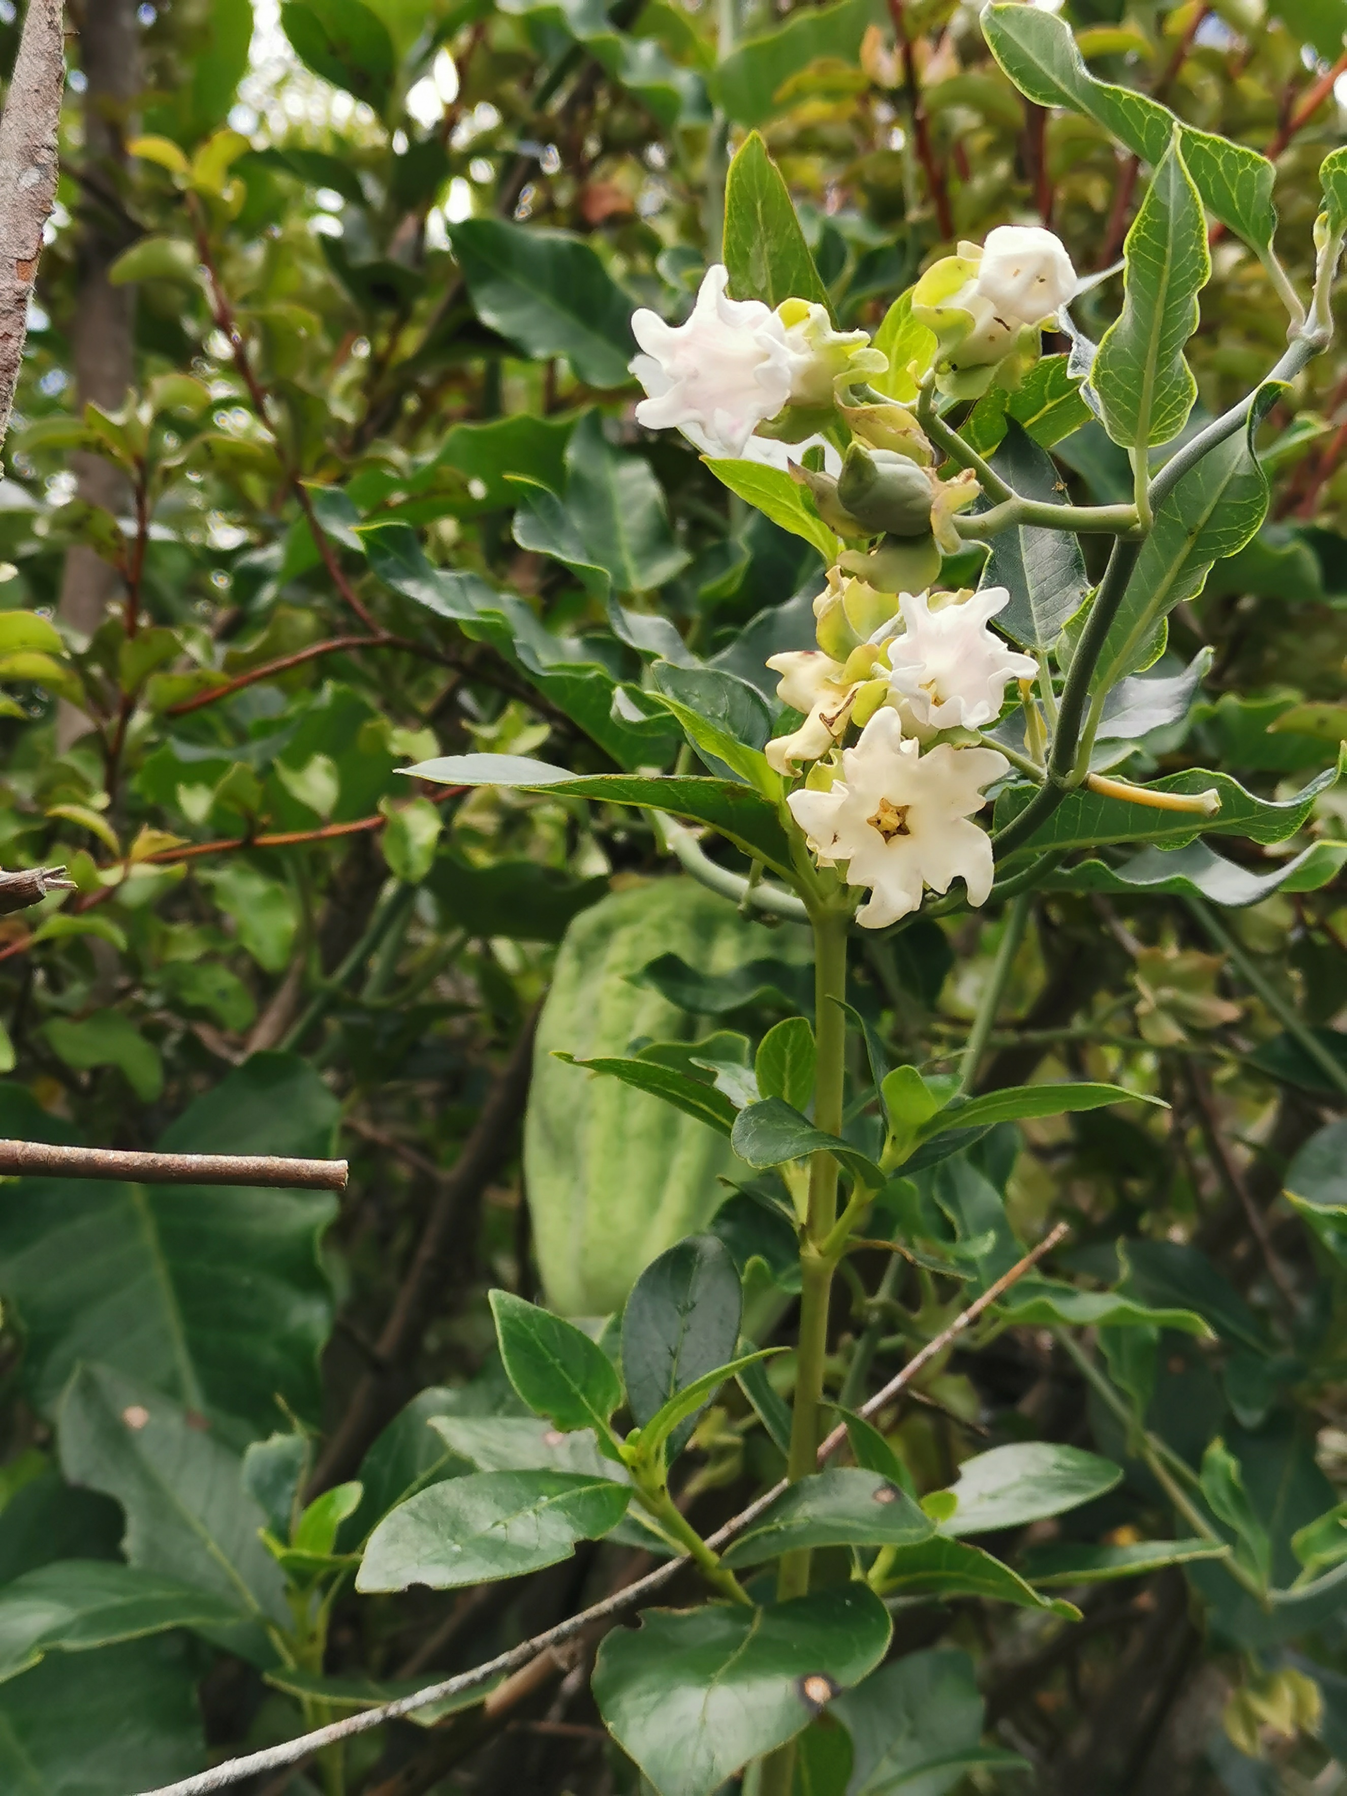
Moth plant flowers and pods. Photo: Whareora Landcare

Considerable effort and resources were also put into controlling these invasive plants within the pine forests managed by the Martin Trust and NRC.

Communication
& Engagement
The Kiwi Link website and Facebook page continues to showcase the project and help landowners find out about local ecological information and how they can get involved.
Kiwi Link had a stall at the Backyard Kiwi release as info and maps on display at the Whangarei Summer Show and Northland Field Days. This helped to share information and engage further local landowners in the project.
The Kiwi Release with Backyard Kiwi at Parua Bay in March 2025 was attended by approximately 375 people. This gave Kiwi Link landowners an opportunity to briefly meet kiwi up close, increase their understanding of how to help kiwi thrive and the importance of sustained trapping and toxin pulses for the survival of kiwi and other native wildlife.
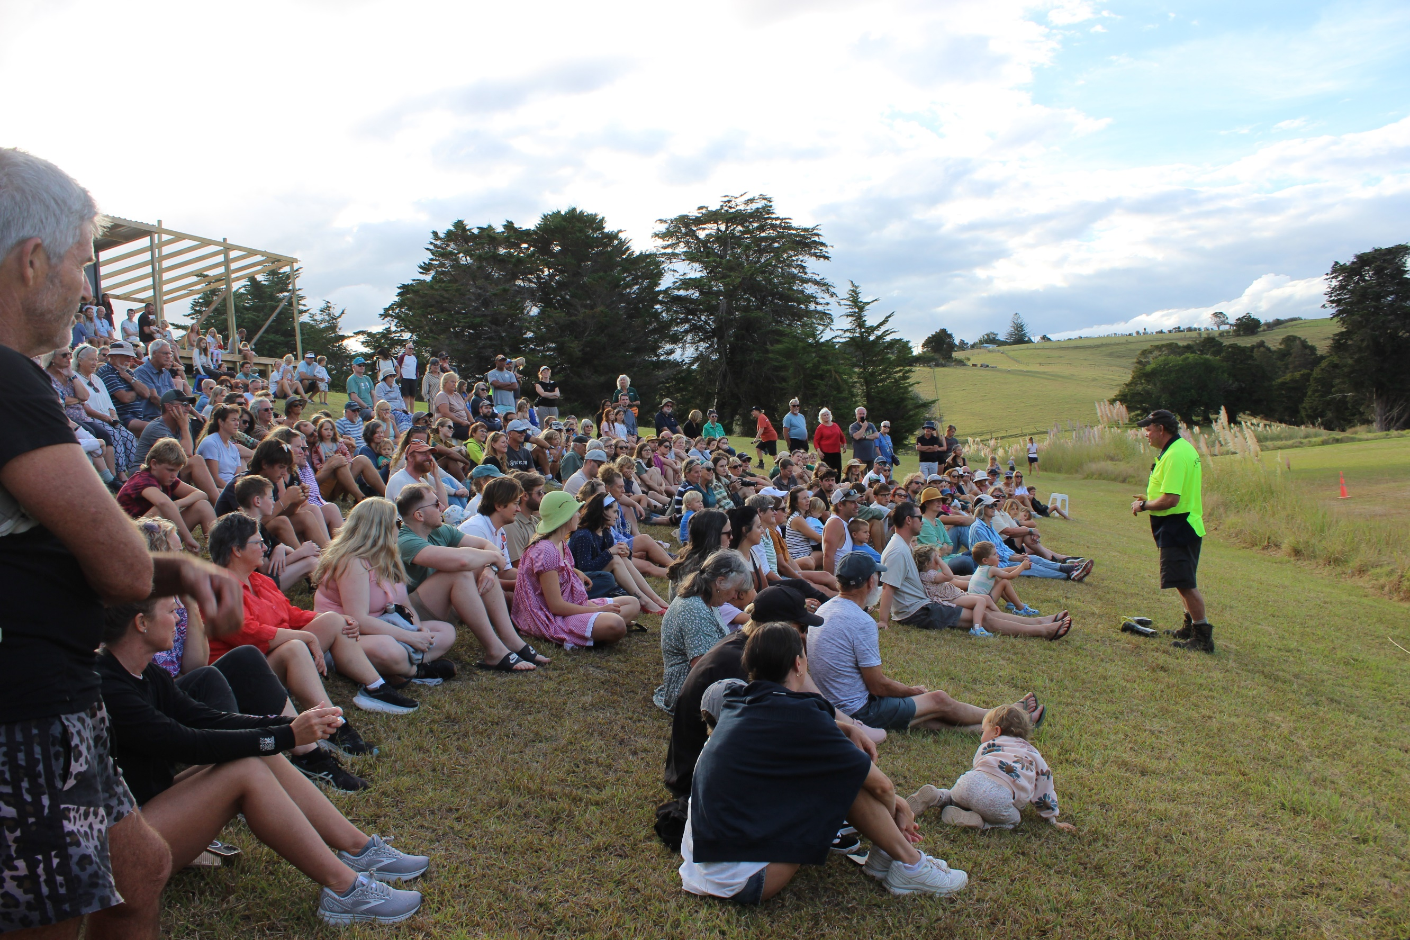
Parua Bay Kiwi Release Event led by Backyard Kiwi

Photos: Carlyn Condon.

Supporting and engaging local dog owners to keep their canine companions safe and secure is essential. Uncontrolled dogs remain the biggest threat to adult Northland kiwi and can quickly undo years of hard work.
‘Kiwi Live Here – Please Control Your Dog’ signs were supplied to landowners and land managers throughout Kiwi Link upon request.
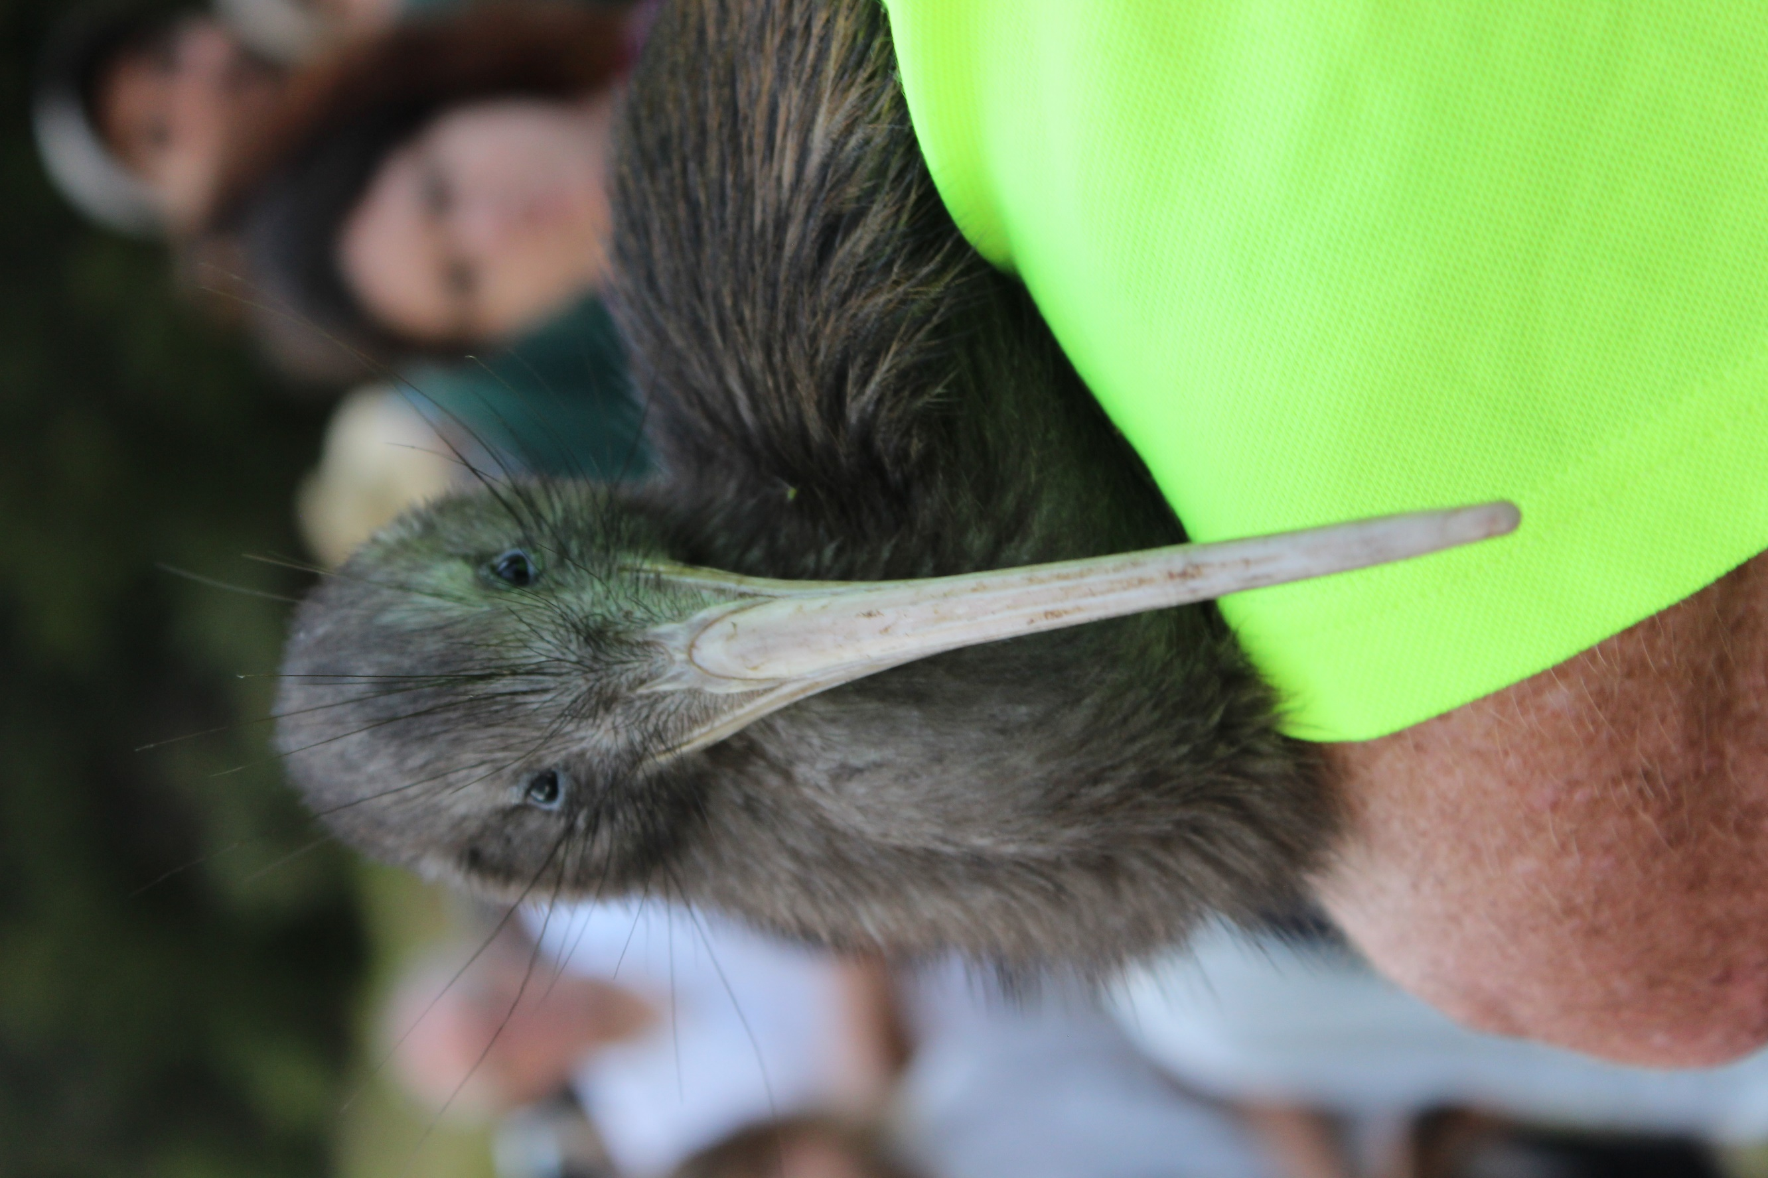
Ping the kiwi at her evening release
Monitoring
All scheduled monitoring
has been completed.

Animal Pests
All Kiwi Link projects recorded their trap catches and submitted their results to Kiwi Coast as part of the annual collation of Northland data.
During 2024, Kiwi Link groups and projects trapped a further 10,387 animal pests (Table 2). Collating the trap catch data gathered since Kiwi Link began shows that a total of 67,388 pests have been trapped since 2017 (Table 3).
Outcome monitoring (e.g. Five Minute Bird Counts) shows the removal of tens of thousands of roaming animal pests has helped to restore birdsong to the once near-silent forests across the Kiwi Link area.
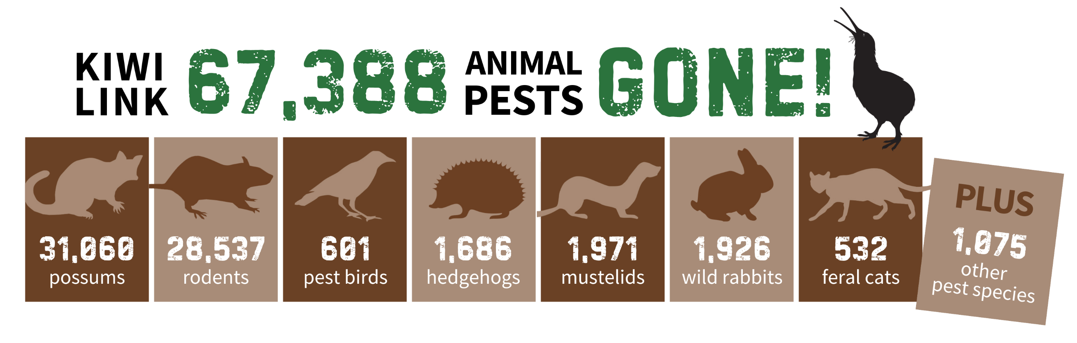

Professional pig control also supported projects where extensive damage to forest floors and endangered native snail populations (e.g. Amborhytida dunniae) had become persistent.
The NRC Biosecurity team helped to coordinate feral pig control across the Kiwi Link HVA, working with local and professional hunters to ensure high Health and Safety standards, Kiwi Aversion Training for the hunting dogs and Kauri Dieback Disease spread prevention measures were all rigorously observed.

Table 2: Kiwi Link Trap Catch Data by Group or Project 2024
Note: Trap catch results only - actual tally will be higher as does not include pests controlled with toxins
Group or Project | Possums | Rats | Ferrets | Stoats | Weasels | Feral Cats | Wild Rabbits & Hares | Feral Pigs | Magpie | Myna | Hedgehog | Mice | Other catches | Total
Harris Road Area Landcare | 117 | 57 | 0 | 0 | 3 | 2 | 41 | 0 | 0 | 0 | 0 | 21 | 0 | 241
Hillbilly Trappers | 132 | 75 | 0 | 0 | 0 | 0 | 0 | 0 | 0 | 0 | 0 | 10 | 0 | 217
Kohinui Stream Landcare | 275 | 654 | 0 | 4 | 1 | 3 | 21 | 0 | 1 | 6 | 13 | 118 | 0 | 1,096
Glenbervie Landcare | 42 | 73 | 0 | 0 | 2 | 1 | 3 | 0 | 0 | 0 | 10 | 0 | 0 | 131
Glenbervie Pest Control | 142 | 137 | 0 | 6 | 7 | 4 | 3 | 0 | 0 | 3 | 12 | 9 | 0 | 323
Mangahui Road Landowners | 52 | 26 | 0 | 1 | 0 | 0 | 1 | 0 | 0 | 0 | 3 | 0 | 0 | 83
Manulife Whanui Project | 91 | 179 | 0 | 19 | 21 | 3 | 0 | 0 | 0 | 0 | 11 | 0 | 0 | 324
Ngunguru Ford Rd & Sandspit | 52 | 197 | 0 | 20 | 25 | 7 | 5 | 0 | 0 | 0 | 7 | 0 | 2 | 315
NRC Taika Block | 40 | 33 | 0 | 1 | 3 | 0 | 0 | 0 | 0 | 0 | 3 | 0 | 0 | 80
Owhiwa Landcare | 746 | 426 | 0 | 22 | 2 | 10 | 32 | 0 | 0 | 19 | 9 | 22 | 7 | 1295
Pataua North Landcare | 568 | 676 | 0 | 26 | 38 | 1 | 326 | 1 | 0 | 8 | 42 | 68 | 0 | 1754
Pataua Farms Est. | 8 | 13 | 0 | 1 | 8 | 0 | 1 | 0 | 0 | 0 | 4 | 3 | 0 | 38
Taraunui Landcare | 10 | 208 | 0 | 3 | 17 | 0 | 12 | 0 | 0 | 0 | 5 | 1 | 2 | 258
Taheke Land Care | 893 | 639 | 0 | 18 | 48 | 5 | 20 | 38 | 0 | 0 | 13 | 46 | 0 | 1720
Whareora Landcare | 1258 | 808 | 0 | 14 | 31 | 26 | 57 | 8 | 9 | 6 | 26 | 257 | 12 | 2512
Totals | 4,426 | 4,201 | 0 | 135 | 206 | 62 | 522 | 47 | 10 | 42 | 158 | 555 | 23 | 10,387

Table 3: Kiwi Link Trap Catch Data Summary, 2017 – 2024
Note: Trap catch results only - actual tally will be higher as does not include pests controlled with toxins

Year | Possums | Rats | Ferrets | Stoats | Weasels | Feral Cats | Wild Rabbits & Hares | Feral Pigs | Magpie | Myna | Hedgehog | Mice | Other catches | Total
2016 | *project began October 2016 - no pest control data for this year
2017 | 3,692 | 2,379 | 1 | 164 | 127 | 48 | 111 | 71 | 11 | 115 | 210 | 291 | 17 | 7,237
2018 | 2,535 | 2,607 | 0 | 178 | 134 | 46 | 69 | 99 | 26 | 76 | 183 | 208 | 83 | 6,244
2019 | 2,641 | 2,761 | 0 | 125 | 103 | 58 | 186 | 224 | 30 | 74 | 210 | 162 | 22 | 6,596
2020 | 3,843 | 2,313 | 0 | 106 | 95 | 67 | 395 | 144 | 7 | 66 | 230 | 102 | 4 | 7,372
2021 | 4,795 | 3,584 | 0 | 86 | 66 | 98 | 259 | 135 | 31 | 23 | 293 | 118 | 21 | 9,509
2022 | 3,672 | 3,171 | 0 | 102 | 93 | 90 | 248 | 66 | 34 | 22 | 230 | 319 | 39 | 8,086
2023 | 5,456 | 5,305 | 0 | 146 | 104 | 63 | 136 | 64 | 22 | 12 | 172 | 461 | 16 | 11,957
2024 | 4,426 | 4,201 | 0 | 135 | 206 | 62 | 522 | 47 | 10 | 42 | 158 | 555 | 23 | 10,387
Grand Totals | 31,060 | 26,321 | 1 | 1,042 | 928 | 532 | 1,926 | 850 | 171 | 430 | 1,686 | 2,216 | 225 | 67,388
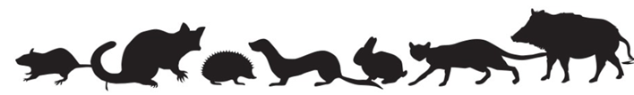

Kiwi
Kiwi are monitored in two ways across the Kiwi Link project:
annual kiwi call listening to measure presence and population trends
by following a small number of kiwi fitted with transmitters to measure breeding, activity and dispersal.
Data from these kiwi monitoring methods over the past 12 months show that Kiwi Link kiwi are surviving, breeding and dispersing successfully.
Annual Kiwi Call Count Survey
All Kiwi Link projects participated in the 2025 Annual Kiwi Call Count Survey, either with human listeners or with Acoustic Recording Devices (ARDs).
Analysis of the 2025 kiwi call count data (Appendix 3) shows that kiwi populations are increasing within the Kiwi Link HVA. In 2023 the highest hourly call rate was seven kiwi calls per hour at the Manulife Whanui “Mussell” site. In 2024, human listening at a new site in the Martin’s Forestry Block identified a 7.25 call/hour rate, while an ARD at the “Kerry’s Back Fence” site, also within the Martin’s Forestry Block, set a new record at 9.87 calls per hour.
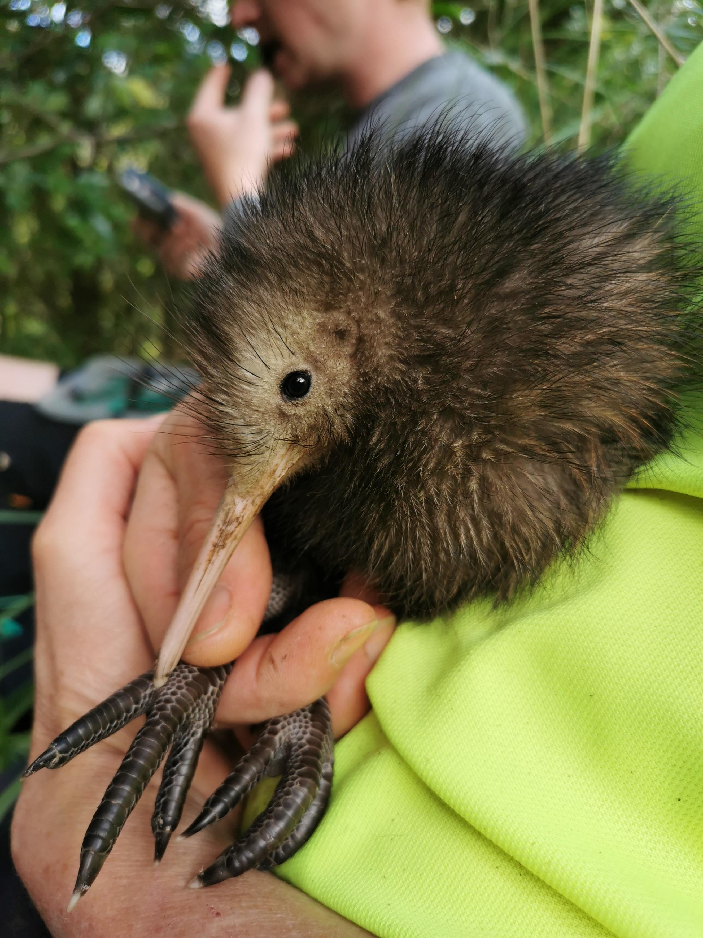
Monitored Pataua Kiwi chick. Photo: Kiwi Link
KLD monitoring also suggests that the
number of breeding kiwi pairs now established within Kiwi Link is also on the rise. This was indicated by the increased number of kiwi duets recorded, which signify breeding kiwi pairs. Every site where duets had been recorded in 2023, had an increased number of duets in 2024.
Monitoring of Radio Transmitted Kiwi
A number of kiwi fitted with transmitters that have either been previously released or have naturally dispersed into the Kiwi Link HVA are monitored by accredited handlers Carl Dowd and Todd Hamilton.
This monitoring has confirmed the successful dispersal of adult and juvenile kiwi, over large distances (5 - 10km) through Kiwi Link’s fledgling “kiwi corridor”, including three released kiwi (Fetu Mama, Te Motu Manu Hine and Fish) (see Appendix 4).
As these kiwi are some of the very few transmitter wearing kiwi in Northland, it can be assumed that other wild kiwi in the Kiwi Link area are also dispersing large distances to find themselves mates and explore new territories.
Unfortunately, two transmittered kiwi – Fetu Mama and Kotahitanga – were killed by uncontrolled dogs this year undoing the work of so many dedicated dog owners and pest controllers working hard to keep kiwi safe. Without the radio monitoring, these kiwi deaths would have remained unknown. They serve as a stark reminder that uncontrolled dogs are still the main cause of untimely adult kiwi deaths in Northland.
Pāteke

Pāteke/brown teal are the rarest mainland dabbling duck in New Zealand.
Congregations of pāteke at Northland flock sites have been counted annually in February since 1988 to monitor population trends.
Since getting underway in 2017, Kiwi Link has worked with specialist staff at DOC, the Pāteke Recovery Group and NorthTec to assist with the flock counts and investigate new sites in the Kiwi Link area.
Analysis of the 2025 Pāteke Flock Count data showed that the endangered endemic nocturnal ducks continue to flourish on Northland’s east coast where intense predator control has been sustained. However, the 2025 flock count total was less than last year at 532 and this will be closely observed to ensure a downward population trend is not occurring.
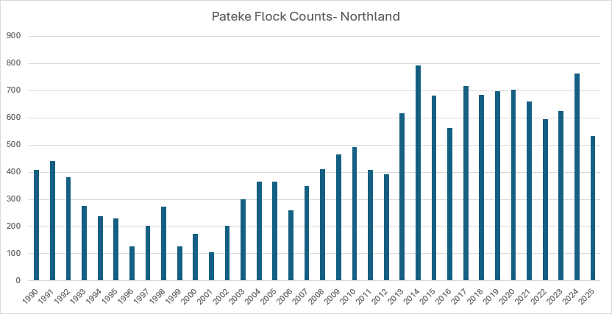
Figure 2: Northland Pāteke Flock Count Data. Source: Department of Conservation,1990 - 2025

Get Max to add an eye

Five Minute Bird Counts
One of the aims of the Kiwi Link is to have flourishing native wildlife. To track progress towards this goal, annual targeted Five Minute Bird Counts have been carried out for the past seven years, using special methodology developed by Dr Dai Morgan.
Eight key native bird species are monitored: tūī, kingfisher/kōtare, grey warbler/riroriro, kūkupa, tomtit/miromiro, fantail/pīwakawaka, kākā and bellbird/korimako.
Each year the results are analysed by
Dr Morgan as shown in Figure 3, with the latest data indicating that native birds are surviving and breeding well across the Kiwi Link HVA in response to the sustained pest control.

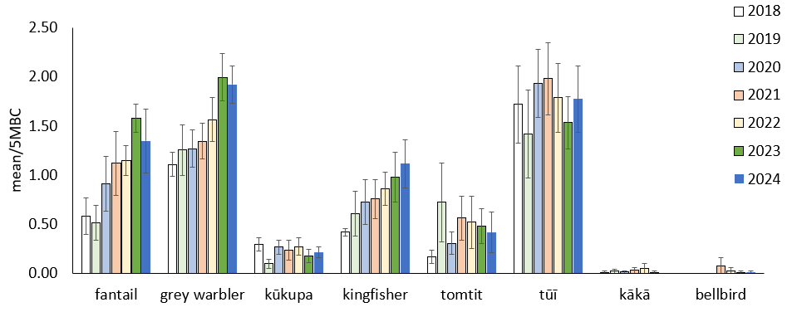
Figure 3: Mean abundance (SE) of key bird species across Kiwi Link Sites (2018-2024)

Dr Morgan commented:
“Bird monitoring across Kiwi Link continues to reveal healthy populations of key forest species. Riroriro, pīwakawaka and kōtare are showing positive population growth.
Meanwhile, tūī and kūkupa have maintained stable numbers. Although the miromiro has experienced a slight decline in recent years, these changes fall within the expected margins of error for this relatively uncommon bird.
Unfortunately, kākā were not detected during this year's monitoring. However, it is encouraging to note that korimako (bellbird) were once again recorded within Kiwi Link.”

Summary
Kiwi Link has had another successful year with good progress made towards all five objectives. All groups involved have worked well together, carrying out animal and plant pest control and monitoring over 15,000 hectares.
In addition to NRC Kiwi Link and Kiwi Coast funds provided during the 2024/25 financial year, local land managers, businesses and private landowners contributed $510,015 of unpaid labour and resources. This significant contribution demonstrates the outstanding commitment and dedication of the groups and projects involved to revitalise their native forests, wildlife and kiwi.
Pest control across Kiwi Link continues to grow as more landowners get involved and groups expand and intensify their operations. New predator traps and bait stations installed into key gaps, thanks to additional funds from Predator Free Whangarei, helped to further link traps and bait stations of neighbouring groups together into a growing combined predator control network. As Kiwi Link lies at the heart of the Whangarei 60,000ha mustelid suppression zone, it plays a critical role in this project.
The removal of 67,388 roaming animal pests over the past nine years has improved forest health and helped to restore birdsong to the once near-silent forests.
Kiwi are also going from strength to strength within the Kiwi Link HVA as evidenced by increasing kiwi calls, rising number of breeding pairs and monitoring of kiwi survival, dispersal and breeding success. The confirmed kill of two monitored kiwi by uncontrolled dogs however, shows there is more work to be done to support and encourage responsible dog ownership.
The achievements of the Kiwi Link HVA will also be resulting in a beneficial ‘halo’ effect for the adjoining Whangarei Heads and Tutukaka biodiversity strongholds. Less pests will be re-invading these areas and native wildlife will be spilling into them.
Kiwi Link is grateful for NRC’s continued support and resources over the past nine years. The strong working relationship formed with NRC Biosecurity and Biodiversity teams has provided a strong foundation for the success of the project.
Many thanks also to Dr Karen Verdurmen for meticulously analysing hundreds of hours of kiwi listening data and to Todd and Carl for tirelessly traipsing through gorse, pine, scrub and pampas tracking roaming kiwi.
Finally, huge thanks to all the private landowners, professional predator trappers and land managers who have been servicing traps, filling bait stations, counting birds and collecting data for the past nine years (and more!). The immense community effort and leadership remains the key to success. Without it, our local native forests and wildlife would have remained in decline.

Appendix 1: Kiwi Link Budget & Expenditure July 1 2024 - June 30 2025

Appendix 2: Kiwi Link HVA Financial Contributions & Unpaid Labour, July 1 2024 – June 30 2025 (excl. GST)

Appendix 3: Kiwi Call Monitoring Results 2020 – 2025
NS = Not surveyed, HL = Human listening, F= Faulty KLD

Appendix 4: Update of Radio Transmitted Kiwi in or near the southern end of Kiwi Link.
Todd Hamilton, Kiwi Coast
Accredited Kiwi Handler, July 2025
  - Chookie – An adult male released at Parua Bay in 2021. He quickly found a mate and began nesting. He has remained in the Martins’ dog free Forestry block on Owhiwa Road. After successfully nesting each season since 2021 he again nested twice this season and added another 3 kiwi chicks to the population. He has already started nesting again in June 2025.

  - Teina – He was released at Parua Bay in 2019 and moved his way into the Kiwi Link area. He is still well settled at Martins’ Forestry block east of Owhiwa Road. We found him in a burrow with a wild hatched adult female (no ID chip) in July 2023. Despite having a female kiwi with still showed no nesting activity this season and remains a very heavy 3475g in weight. This is very fat for an adult male kiwi!

  - Beach Girl - This adult female was rescued from the DOC Motuora Island crèche during the 2020 drought and released at Taraunui Road. She quickly regained weight and health to 2500g in weight after being a very skinny 1500g on rescue. In 2023 she moved NW to the Halses’ property on Ross Road and has been settled there. She continues to be in good health and may well have found a mate.

  - Murdoch – He was transferred via the Parua Bay public kiwi release event to Owhiwa Road in March 2023. This 7-year-old adult male headed north to the regenerating bush at the end of Ross Road. The released female kiwi Om travelled with him and they paired up and successfully nested there. They had another successful nesting season this year hatching 3 chicks from 2 nests.

  - Humphries - This male kiwi was transferred from Limestone Island via Whangarei Heads School to Owhiwa Road in June 2023. After heading into the native bush to the north he returned to the pampas and pines of his release site. He has found a mate in this area and they successfully hatched their first chick this year – named “Fern” by Whangarei Heads School.

  - Fetu Mama - This female kiwi was released in March 2023 and settled in the pampas and pines on Owhiwa Road until August before walking North. We tracked her to the Maungatika Scenic Reserve, in the Whareora Landcare managed area, way up the top of Tiger Mt. This is over 5 km in a straight line with plenty of valleys, creeks and ridges in between – she may have used Owhiwa road to help her make the journey. After spending time there she headed into the nearby WDC pine block where she was killed by an uncontrolled dog in December 2024.

  - Te Motu Manu Hine - This female was transferred via the Whangarei Heads School to Owhiwa Road in June 2023. She didn’t take long to go walk about – heading almost 10km north to the NRC pines on Mt Tiger Road. When things got dry in the autumn of 2024 she headed into the deep valleys between Mt Tiger and Onerahi. She is now well settled in the NRC pine block behind the old Money Factory. She is now 4.5 years old and may well have found a mate for her to remain in a small area after so much travelling.

  - Fish - This young kiwi was hit by a car at the Whangarei Heads in November 2022. Luckily it was his tough rear end that got hit not his fragile chest and head. He was held for observation and then released with a transmitter away from roads and dogs at Owhiwa Road. His health and activity was monitored and he made a full recovery, so much so that he made a massive walk northwards to almost the Horahora river. He has since been monitored by Pataua North Landcare in their managed area and continues to move around.

  - Tanker – In November 2023, a year after Fish was rescued; another kiwi was hit by a vehicle on Whangarei Heads Road – this time by a Milk Tanker! He had a spell at the WNBRC before being released a few days later. Named “Tanker” he was closely monitored via his radio transmitter data stream for his activity. He recovered well and settled in the pampas and pines on the eastern side of Owhiwa Road. In September 2024 his radio transmitter band broke and the transmitter fell off.

  - Manaaki – Male kiwi released in February 2024. He was settled in the pines and pampas on the eastern side of Owhiwa Road then did a big loop to the north before returning to his release area and dropping his transmitter.

  - Kotahitanga – A young male kiwi released in February 2024 at Parua Bay. He spent a few weeks there before legging it north to the Pataua North Landcare area. He was monitored there until he was killed by a wandering dog in January 2025.

Kiwi released in 2024-25 Season:
With the extremely dry late summer/early autumn kiwi on the Matakohe - Limestone Island crèche struggled for food and were in very poor condition. Four kiwi were carefully transferred to a safe pine block at Owhiwa Road in late March and they quickly regained condition in the better feeding conditions there:

  - Kim – A young female kiwi that went from a skinny 1200g on release to 1625g a month later. She has since remained in the pine block on Owhiwa Road.

  - Myra – A young female kiwi that has settled well in the pines and pampas on the eastern side of Owhiwa Road.

  - Ping – An adult female kiwi that was a very skinny 1550g on release but recovered to 2000g a month later. She was settled in the pines and pampas at the start of Owhiwa Road but disappeared for a month before returning.

  - Matakohe – A young male kiwi released in March 2025 who was initially settled on the pine block on Owhiwa Road but headed north from there in June. Unfortunately, he only got a few kilometres north before he was killed by a wandering dog at the end of Ross Road.

There will be other kiwi without radio transmitters that have moved from the Backyard Kiwi managed area into the Kiwi Link area. The estimated population on the Whangarei Heads peninsula has grown from approximately 80 in 2001 to over 1,100 in 2024 and the kiwi there disperse outwards in to the neighbouring Kiwi Link area.
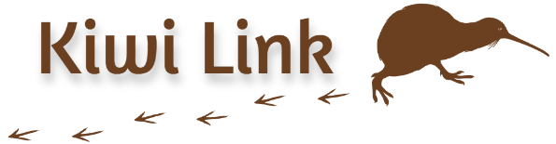
Report prepared by Ngaire Sullivan, Kiwi Link HVA Coordinator, July 2025.
Design by Abby Davidson Design.

